BIOC 455
Lecture # 19– Neuronal Membrane Transport Mechanisms I
Lecturer: Dr. Tak Pan Wong – February 16th, 2007

NOTE: This NTC is meant to be used as a study aid to supplement your own class notes. Hence, not all of the text or diagrams contained in the lecture slides will be reproduced here.

Please send any comments or questions about NTCs to either Wanda or James through e-mail at u3.represent@gmail.com .

This lecture started with material from the Glutamate and GABA. It mainly focuses on ion transporters.

GABA cycle
The opening of GABA receptors will cause Cl- ions to enter the cell, leading to hyperpolarization. Remember that glutamate is a precursor of GABA
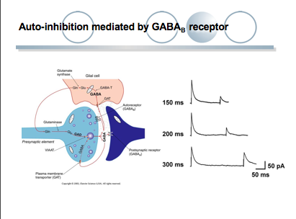 | GAD (glutamic acid decarboxylase) will remove a carbon ion from glutamate and this will give GABA. Glial cells will re-uptake GABA and transform it back to glutamine. The glutamine will then be made into GABA. They will continue in this fashion and follow this cycle.

GABA_{B} receptors
- are metabotropic receptors (GPCR)
- Mediates postsynaptic inhibition via the activation of inward-rectifying K channels.
- Activation of these receptors will lead to hyperpolarization of the presynaptic terminal following the activation of K channels.
- Important for auto-inhibition when located in presynpatic GABA terminals.

Auto-Inhibition mediated by GABA_{B} receptors
- will lead to the inhibition of neurotransmitter release
- the release of GABA will activate GABA_{B} receptors on the same terminal and resort to a feedback mechanism.
- The release of GABA as a negative feedback loop will maintain the length of effect of GABA, not to be blackout of control.
- The release of the first stimulus will activate GABA_{B} and this will hyperpolarize the cell. If you decrease the time between two stimuli, you can see the response of the second stimulus kept decreasing, this is due to the fact that the first stimulus causes the release of GABA and at the same time will activate GABAB leading to the hyperpolarization of the terminal. If you decrease the time between the two stimuli, the effect is more important. In this case, when you decrease to 150 ms, you get the stronger inhibition, due to the release of GABA from the same terminal.

NMDA receptors and Schizophrenia
- recall that NDMA receptors are excitatory
- compounds such as PCP, can cause psychotic effects that will exaggerate the symptoms of schizophrenia.
- If you inject these compounds in healthy individuals, symptoms of the disease also arise.
- These compounds act by blocking the NDMA receptors, which creates hallucinations. Schizophrenia is said to be due to the reduction in NMDA activation. Therefore, NDMA receptors can be a therapeutic target for the treatment of this disease.

NMDA receptors and Excitotoxicity
- consumption of a large amount of glutamate will not lead to excitotoxicity since the Blood Brain Barrier(BBB) forbids the passage of glutamate. However, high levels of glutamate can damage neurons in the circumventrical organs such as the pineal gland.

NDMA and AMPA
- AMPA can also be permeable to Ca+ if it doesn’t contain a GluR2 subunit.
- Q→R site modification, the AMPA receptors with GluR2 are not permeable to Ca+. In other GluR subunits it’s a Q. Therefore, if you mutate the GluR2 from R into Q, you will have Ca+ permeability.

The accumulation of Ca+ causes all the damage; this leads to the creation free radicals and activation of some enzymes that causes protein and DNA fragmentation.
(The Prof mentioned this right before starting the Transporter 1 topic)

Membrane Transporters
- Function: to maintain the ion gradient
- They are ubiquitous proteins (present everywhere)
- 40% of the energy used in the brain is given to transporters.

Primary transporters, Secondary transporters and facilitators:

Primary transporters are ATP coupled transmembrane protein. They require the hydrolysis of ATP. The ion gradient is due to the presence of these transporters. (recall the concentration of different ions, slide 5)

Secondary transporters, like antiporters and symporters, require the gradient imposed by primary transporters. For example, the Na+/neurotransmitter symporter require a Na+ gradient.

A facilitator doesn’t require a gradient, nor does it require a lot of energy to function. It simply “facilitates” the entry of some molecules.

Primary Transporters
There are three types of primary transporters:
- P-type: These are the major players in maintaining the ion gradient.
- V₀V₁ Pumps: these are proton pumps. They pump H+ in membranes derived by Golgi.
- ABC type transporters: mostly for transport of cholesterol and phospholipids. Not discussed further.
- Responsible for 40% of energy consumed by the brain
- These transporters have low efficiency (10 000 ions/min; compared with 3000- 5000 ions/ms in ion channels)

The efficiency of ion transport through primary transporters is very low. It can only permit 10 000 ions per minutes. Therefore, you need a lot of transporters.

Na+/K+ ATPase
- this transporter is ubiquitously expressed
- the hydrolysis of ATP will cause the translocation of 3 Na+ molecules out and 2 K+ molecules in
- this is an electrochemical gradient and thus requires energy
- hypolarizes membrane by 10 mV
- a selective inhibitor is ouabain

Step by Step
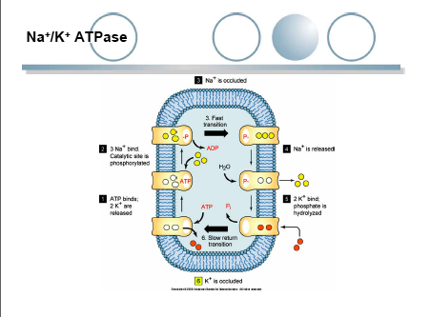 | - the first step requires the binding of ATP.  - The binding of ATP will cause the binding of Na+ molecules.  - The hydrolysis of ATP -> ADP will follow, leading to a conformational change of the transporter due to phosphorylation.  - Na+ molecule can now leave the cell.  - The dephosphorylation of the transporter will cause the binding of K+ into the channel.

Structure of the Na+/K+ ATPase
- this structure consists of multiple subunits, including 10 transmembrane domains  - this domain containing α subunits does everything like binding ions and ATP.  - There are phosphorylation sites on the α subunits for the regulation of the transporter.  - There are three type of α subunits: α1: Schwann cells and some neurons; α2: glial cells; α3: neurons. α1 subtype is the most common. | 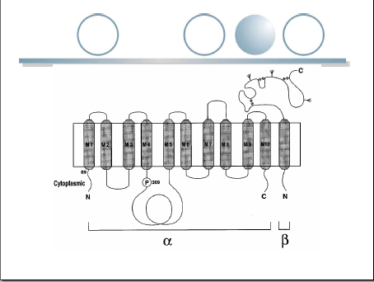

- The β subunit is monotopic- this means that it only has one transmembrane domain.
- It is involved in correct folding and membrane insertion of the α subunits.
- A modulatory γ subunit has also been identified.
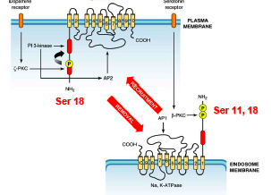 | - these phosphorylation are used in the regulation by the dopamine receptor, a GPCR. Activation of this receptor will activate ζ-PKC which phosphorylates a Serine 18 residue as shown on the figure to your left. This will decrease the amount of the ATPase at the surface.

- activation of a serotonin receptor, also a GPCR will activate β-PKC which phosphorylate Serine 11 and Serine 18. This will lead back to the recruitment of the transporter to the membrane. Phosphorylation is therefore an important method of regulation.

Na+/K+ ATPase and disease
- A malfunction in this transporter can lead to diseases such ischemia and Alzheimer’s disease (related to a decrease in α3 mRNA)
- In heart disease however, a selective blocker for this ATPase can be a good thing, regardless of the fact that it’s such an important protein.
- Inhibition of this ATPase will lead to an increase in intracellular Na+, leading to a decrease in the Na+ gradient. The concentration of Ca+ will increase and this will lead to enhanced heart muscle contractibility.
- Compounds such as ouabain and digoxin can therefore help treating some diseases.

Ca²⁺ transport
- there is a about 10 000 fold difference between the concentration of Ca²⁺ outside the cell and inside the cell, the concentration of Ca²⁺ outside being 1200 μM compared to inside which is 0.1 to 0.01 μM.
- Ca²⁺ are important second messengers, therefore we do not want to trigger them unnecessarily.
- Calcium transport is also involved in Ca²⁺ dependent K+ channel for repolarization.
- Ca²⁺ is also stored intracellularly, in the endoplasmic reticulum. You have high concentration of Ca²⁺ in the ER whereas in it is low in the cytoplasm.

There are three main types of Ca²⁺ pumps:  - P type Ca²⁺ pump (PMCA): this has high affinity to Ca²⁺ but low efficiency, 1 ATP used will equal to 1 Ca²⁺ moved. The binding of calmodulin will increase the affinity for Ca²⁺  - Na+/ Ca²⁺ antiporter: this requires a Na+ gradient. One Ca²⁺ will be replaced by 3 Na+ ions. No ATP is required.  - SERCA: this pump is present in the ER. Hydrolysis of 1 ATP will pass 2 Ca²⁺ ions into the ER  The receptor IP3 mediates the deflux of Ca²⁺ back into the cytoplasm. IP3 is a second messenger that will cause this. | 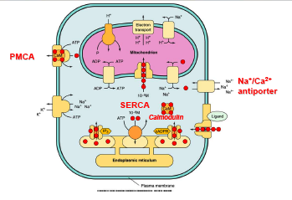

All three type of transporter require ATP, even the Na+/ Ca²⁺ antiporter since this transporter requires a Na+ gradient in order to function, but this gradient is created by primary transporters, which requires ATP. Therefore, indirectly, they all require ATP.

Transporters that removes neurotransmitters from synaptic cleft

Removal of glutamate by glial cells
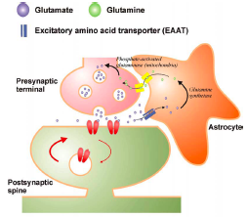 | - this removal requires the transporter Excitatory amino acid transporter (EAAT)  - this transporter also works for GABA and other neurotransmitters  - It is an Na+/neurotransmitter symporter.  - Using the Na+ gradient, the influx of Na+ will carry with neurotransmitters with it back into the cell. Same thing happens in glial cells.  - There are 5 major subtypes of glutamate transporters, most important are GLAST and GLT-1 in glial cells.

Neurotransmitter symporter
- Contains at least two types:  Na+/Cl- dependent transporter for GABA, glycine, noradrenalin, dopamine and serotonin (12 transmembrane domains.  Na+/K+ dependant transporter for glutamate (10 transmembrane domains)  - Another type is a V₀/V₁ transporter: the consumption of ATP will cause protons to enter the presynaptic vesicle, making it acidic. This transporter requires a proton gradient. You can concentrate glutamate in these vesicles. Important for glutamate release during synaptic transmission.  - The transporter at the bottom of the figure on the right requires an Na+ gradient. This is maintained by the Na+/K+ ATPase at the top of the figure.  - There is 80% of glutamate uptake in the cell. | 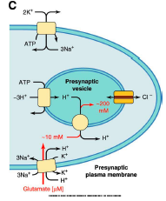

Ischemia and excitotoxicity.
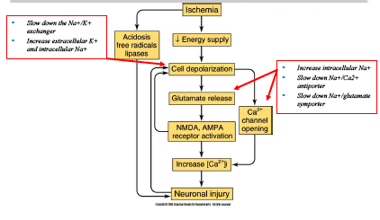 | - due to high intracellular Na+, the antiporter for removing Ca²⁺ will no longer work., since the there is no Na+ gradient.  - There will be glutamate release in the synaptic terminal and accumulation.  - This will lead to the activation of gluR and NMDA  - Leading in increase in intracellular Ca²⁺  - Causing neuronal injury.
- if you have higher levels of glutamate transporter, you are more protected in response to stroke and excitotoxicity such β-lactam.

K+/Cl- symporter (KCC2)
- required to shoot Cl- out, in order to maintain the Cl- gradient.  - Until postnatal day 16 in rats, before the expression of KCC2, the concentration of Cl- inside the cell is 25mM, due to the electrochemical gradient and the presence of other ions. Cl- will removed from the cell. In this case, the opening of GABA receptors will be excitatory. This is important for cell signaling for normal development of the brain.  - With KCC2, you can actively exit the Cl- ions. | 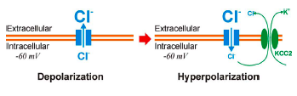

Facilitators
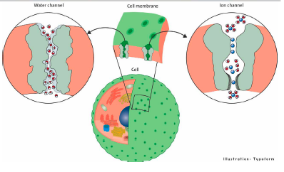 | We will consider water channels.  - you need channels/holes for the water to pass through  - in the membrane, there are channels for the transport of water  - it doesn’t require a concentration gradient, nor does it require lots of energy  - However, without it, water transport is greatly reduced

